Assignment-19.2:

Convert XML File into Json File Format

You can consider below example XML, save it in the hdfs cluster and then to convert into Json File Format. Share the codes used with the screenshot for the same.

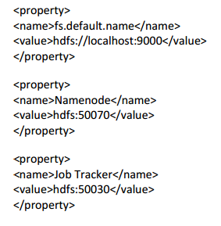

Input File:

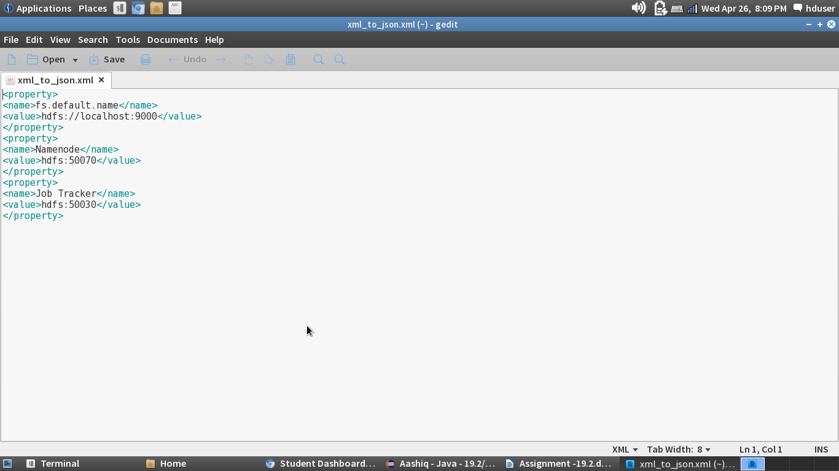

Driver Class:

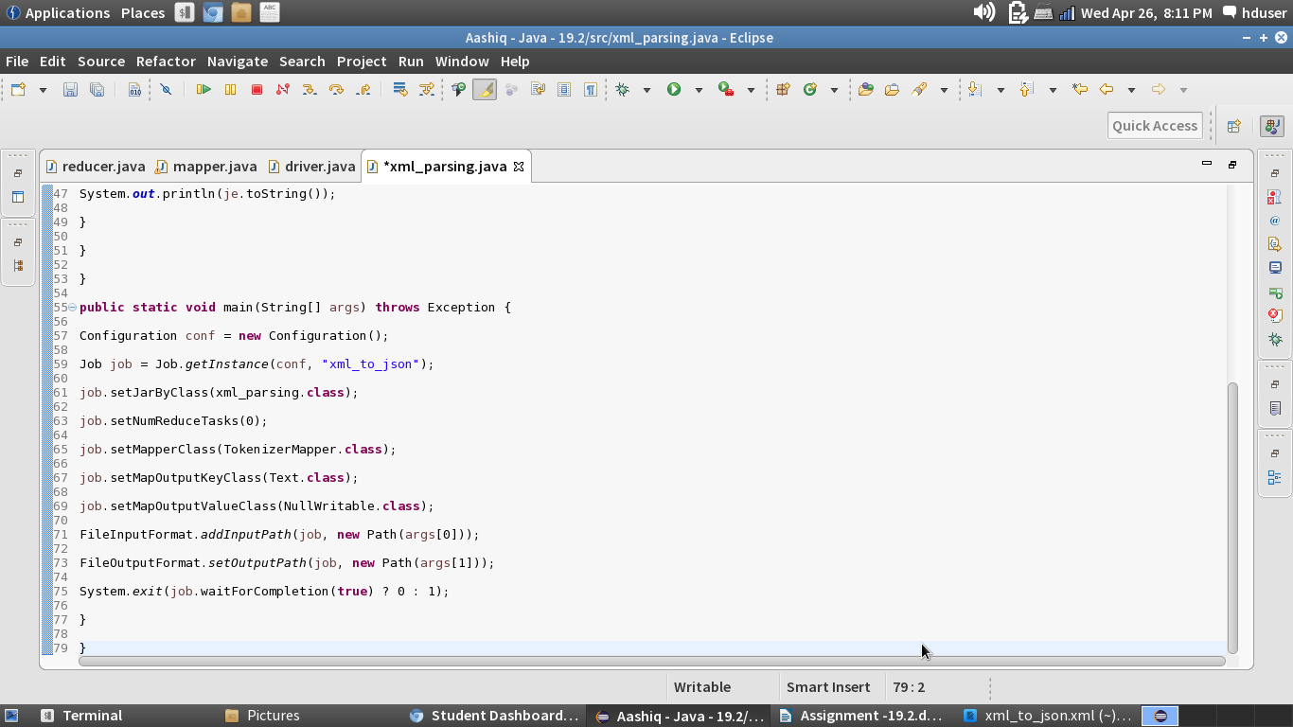

Mapper Class:

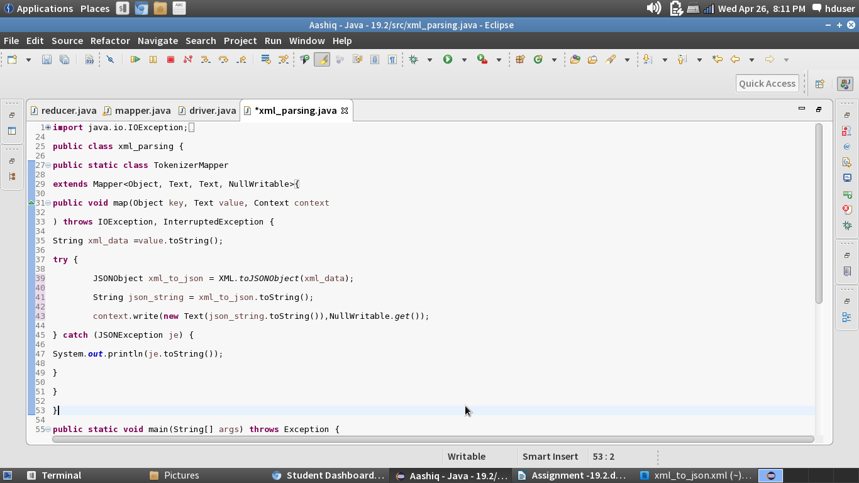

Running the Jar File:

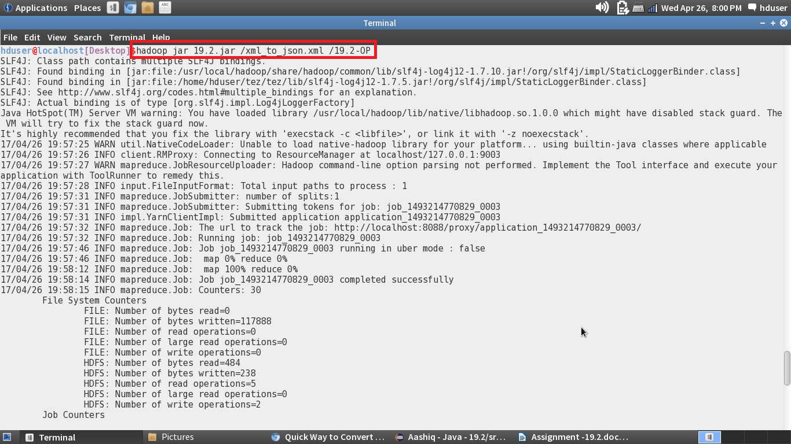

Output File:

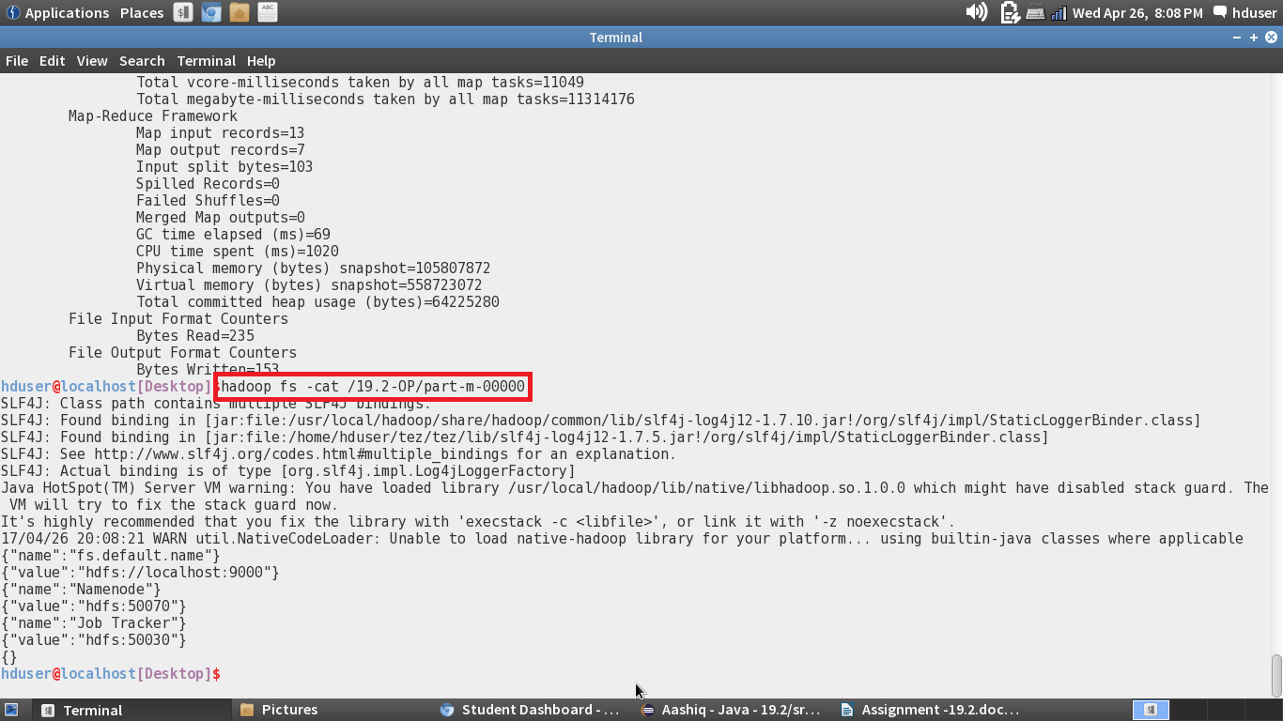

In the above screenshot, we can see that the xml file is converted to Json file format